REGISTER YOUR EVENT OR ACTIVITY
Wandle Fortnight is a celebration of all things Wandle run by the community for the community. Dozens of community-led events and activities are being planned by local community groups and voluntary organisations. Register your event to receive free publicity by completing the details below and emailing them to wandlevalleyforum@gmail.com by September 7th at the latest.

Your details?
- Your name:

- Your group/organisation:

- Contact details: email and/or phone:

Details for our website
The information below will be published on our website and social media pages: -

When and where?
- Event name (in as few words as possible):

- Name of group/organisation or individual holding the event:

- Date(s):

- Start Time:

- End Time:

- Location (for online events please provide a website link):

- Postcode:

- Please can you provide a suitable photograph of your event or logo
(images should be maximum of 2MB)

Describe your event or activity

What tag(s) best describe your activity (delete the ones not applicable and/or add your own)?
art | concert | cycling | dance | craft | exhibition | gardening | gardens | heritage | interactive | museum | music | online |sport |talk | tour | volunteer-work | walk | wildlife

What else will people need to know?
- Is the event free?:

- Do you need to book? (if so, please provide details):

- Are there children’s activities? (if so, please provide details):

- Can children attend?:

- Please provide a contact email/telephone number the public can use (if available):

- Where can people find more information (e.g. website address)?

Wandle Grants – You may be interested in our Wandle Grants scheme and can apply for between £50 and £200 using the application form available on our website.

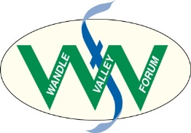
www.wandlevalleyforum.org.uk

